IIIT Bangalore

A Project Report
On

Socket Programming IN C Language

Submitted To
Zense Club

By
Aman Kumar(IMT2018006)

GENERAL OUTLINE OF THE PROJECT

This project is about “Socket Programming”.I made a chat box for communication between server and client.I created two codes,one for the server and other for the client.Exchange of messages can be done between server and client.This server can handle a maximum of 10 clients.

If the client types “close”,then the chat between the server and client is terminated.

Idea

We live in a world surrounded by social media,so the idea was to implement a similar program like whatsapp which would enable transfer of messages from client to server and vice-versa.Basically to make a free message transfer service was the motive behind this project.

FUTURE ASPECTS OF THIS PROJECT

I faced a bit of difficulty in transferring files(text,images and videos) as i could not read the file in binary so transferring files would be a future aspect of my project which i would try to achieve.
Also linking the messages via internet so that many people can share their topics and also back-up of data would be a worthwhile topic for me to work on.

Topics used by me to finish this Project

I used <sys/socket.h>,<sys/types.h> and <netinet/in.h> libraries to use pre-defined functions available to complete my project.
I also took the port number to be 9000,which is greater than 80 so that the port numbers assigned for other protocols wont get used up.

I used TCP protocol for transfer of messages between the server and the client.

I used AF_INET family domain which uses ipv4 protocol.

Overall Experience
It was a fun-based learning experience for me.I got to learn about the practical purposes of programming languages(C language here in this context).Also making a new application made me feel exuberant and facinated.This also brushed my C language skills.

Overall I learnt a great deal from this project.

References to accomplish this task

I learnt socket programming from udemy courses(free) and also from youtube.I also took some help from geeks for geeks site.

Also i browsed information about various domains,protocols and working of a socket from net.

Technology used and Implementation details
+
Firstly i would like to mention some definitions:-

Sockets are basically a low-level connection between any two computers.
Any transfer of data mainly involves 2 protocols:-
1)TCP protocol(Transmission control protocol)
2)IP protocol(Internet protocol)

Protocols control the sendind and receiving of information.
In my project i used TCP protocol for transfer of messages.

The figure shown below is a basic blue-print of how a message is transfered between a client and a server and vice-versa.

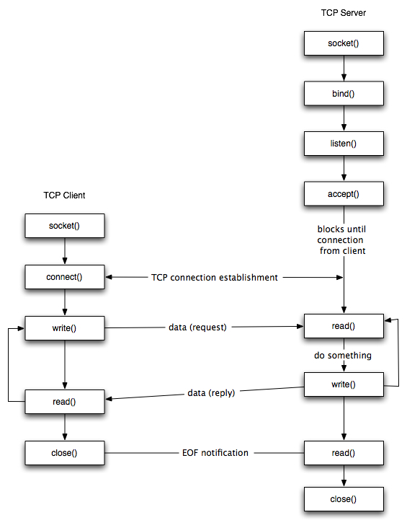

Creating Client socket and Server socket:
We first start by creating a socket for communication.
There is a predefined function socket() which takes
domain,type and protocol as parameters.

The domain here is an address family that is used to designate the type of addresses that our socket can communicate with.We use AF_INET here.(ie. Ipv4 address family).
I am using SOCK_STREAM type of socket which is a TCP socket involving TCP protocol.
We could also use SOCK_DGRAM which uses UDP protocol.

The third parameter is taken as 0 which is a default value for TCP protocol.TCPprotocol is responsible for the data delivery to other computer.
The socket function return an integer(file descriptor).

Overall it looks like:-
socket(domain,type,protocol);

Then we use struct sockaddr_in serveraddr; which is defined in netinet\in.h.

Next we type serveraddr.sin_family=AF_INET;
which mentions the kind of family of address with which we can work with.

Next we write server.sin_addr.s_add=INADDR_ANY
which helps us connect to the local machine.(IP =0 0 0 0).It uses our IP address.
Next we write serveraddr.sin_port=htons(9000);
htons() function converts data into ip address port which the structure understands.Port is a way to connect to some other device usually with a socket.It follows TCP/IP protocol.

9000 is any random port number.It can be any number greater than 80 as numbers below 80 are defined for some predefined protocols.

In client.c we use connect() function to connect to the server.It takes the file descriptor returned by the socket() and a pointer struct sockaddr* which contains information about the destination IP address and port.
It also takes the sizeof struct sockaddr.
It returns -1 on error.
The function looks like:-
connect(int socket_filedescriptor,(struct sockaddr*)&serveraddr,sizeof(struct sockaddr));

In server.c we use bind() function to bind our socket to a specified IP and port.
It takes file-descriptor returned by socket(),(struct sockaddr*) and sizeof(serveradd)) as parameters.
So now our socket is binded to an IP port so we can listen for connections using a listen() function.

In server.c we use listen() function which waits for incoming connections from the client.
It takes file descriptor returned from socket() and number of connections that can be made as an incoming parameter.

It looks like:-
listen(int file_descriptor,int no._of_connections);

Next,in server.c we use accept() function which accepts the pending connection on the port we are listening to.It returns a new socket file descriptor.
It takes file descriptor returned by socket() ,(struct sockaddr*) and sizeof(struct sockaddr).
It returns -1 on error.

In the chat function we use read() and write() functions for communicating over SOCK_STREAM sockets or connected datagram sockets.

It is similar to send() and recv() also.
The read() function take file descriptor returned by the socket() ,message communicated and sizeof(message) as the parameters.

The write() function also takes the same set of parameters.

It looks like:-
write(int file_descriptor,message,sizeof(message));
read(int file_descriptor,message,sizeof(message));

I took the maximum length of each word to be 300 in this case.

Also i wrote while(message[size]=getchar()!=’\n’)
ie. Only when new line gets started,ie. When we hit ‘Enter’ then the message recording stops.

At the end we close the socket using close(file_descriptor);
Here also the file descriptor is returned by the socket() funtion.

When we write ‘close’,then the chat ends as the break; command gets executed and it breaks out of the infinite for-loop created.

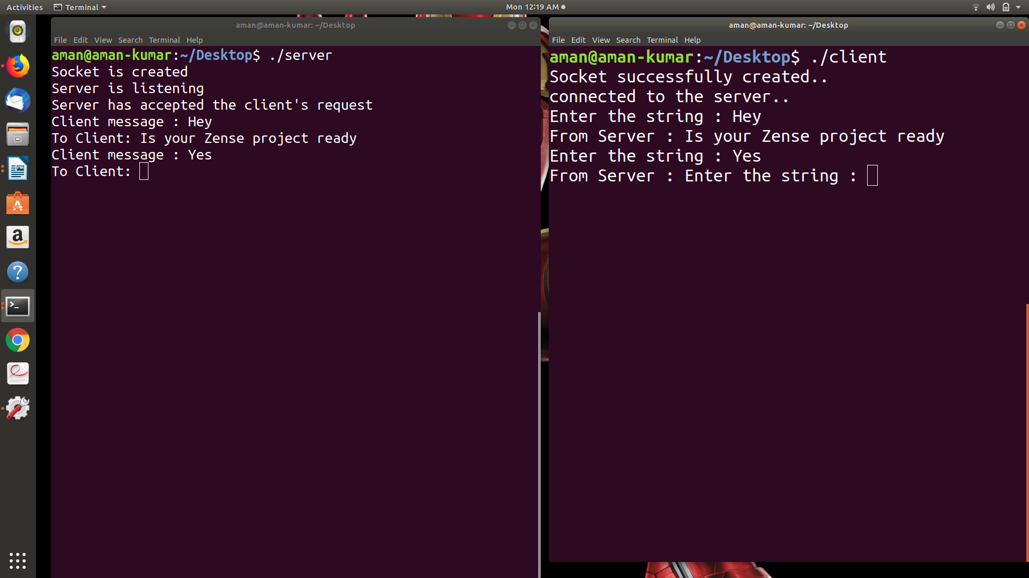
A screen shot of our chat.

